**INDEX**

|  |  |  |
| --- | --- | --- |
| **Prac.**  **No.** | **Practical** | **Date** |
| **1.a** | **Program to calculate number of samples required for an**  **image.** |  |
| **1.b** | **Program to study the effects of reducing the spatial**  **resolution of a digital image.** |  |
| **2.a** | **Basic Intensity Transformation functions :**  **Program to perform Image negation** |  |
| **2.b** | **Program to perform threshold on an image.** |  |
| **2.c** | **Program to perform Log transformation** |  |
| **2.d** | **Power-law transformations** |  |
| **2.e** | **Piecewise linear transformations**   1. **Contrast Stretching** 2. **Gray-level slicing with and without background.** 3. **Bit-plane slicing** |  |
| **3** | **Program to plot the histogram of an image and categorise** |  |
| **4** | **Color Image Processing :**  **a. Program to read a color image and segment into RGB**  **planes , histogram of color image** |  |
| **5** | **Fourier Related Transforms :**  **a. Program to apply Discrete Fourier Transform on an image** |  |
| **6** | **Morphological Image Processing :**  **a. Program to apply erosion, dilation, opening, closing** |  |

**Practical No : 1**

**Aim: 1A ) Program to calculate number of samples required for image. Description :**

The program will only calculate the number of samples required for an image.

**Code :**

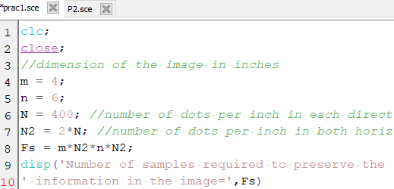

**Output:**

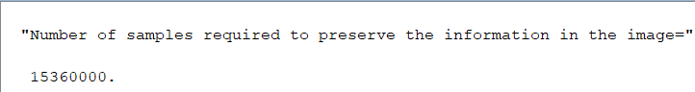

**1 B) Program to study the effects of reducing the spatial resolution of a digital image**

**Code :**

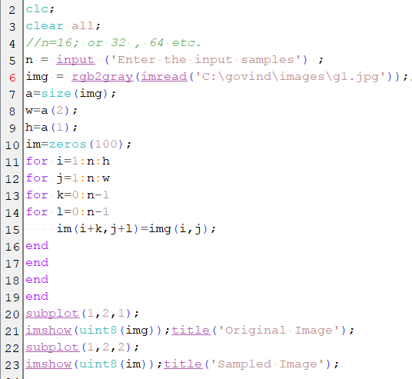

**Output:**

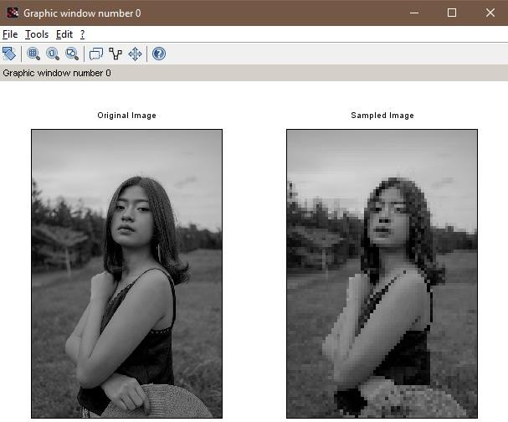

# Practical No : 2

**Aim: Basic Intensity Transformation functions**

* 1. **) Program to perform Image negation**

**Description:**

when you are working with gray-scale images, sometimes you want to modify the intensity values. For instance, you may want to reverse black and the white intensities or you may want to make the darks darker and the lights lighter. An application of intensity transformations is to increase the contrast between certain intensity values so that you can pick out things in an image. For instance, the following two images show an image before and after an intensity transformation.

**Code :**

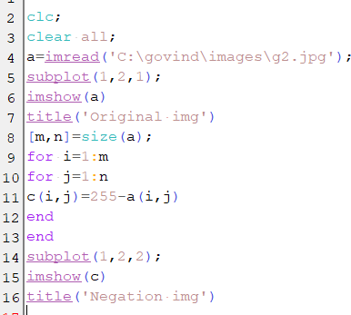

**Output:**

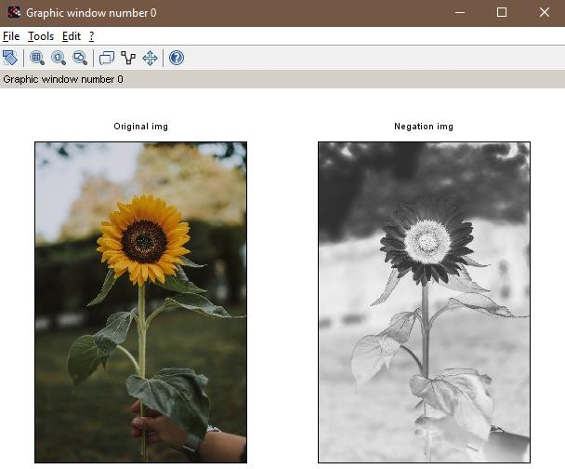

* 1. **) Program to perform threshold on an image**

**Code :**

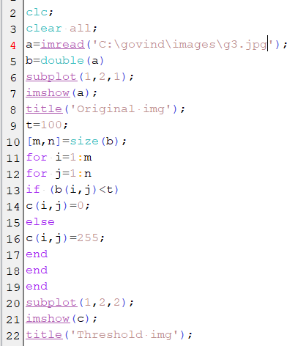

**Output:**

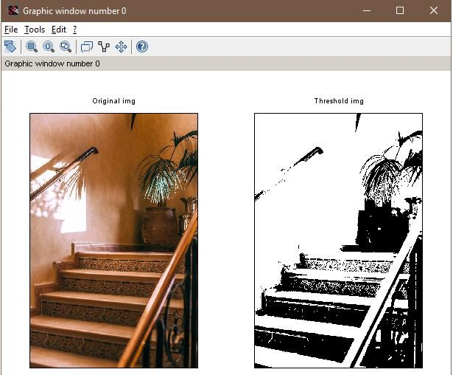

* 1. **) Program to perform Log transformation**

**Code :**

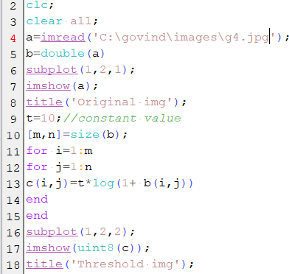

**Output:**

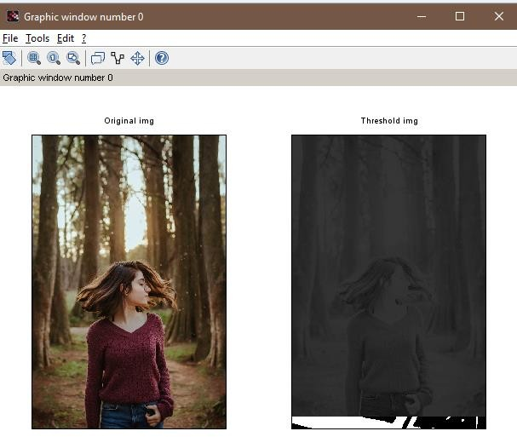

* 1. **) Power-law transformations**

**Code :**

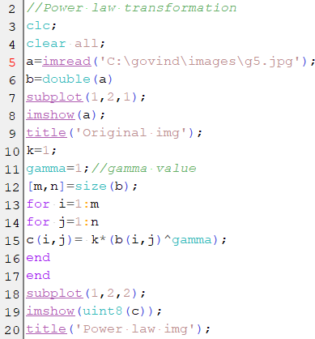

**Output:**

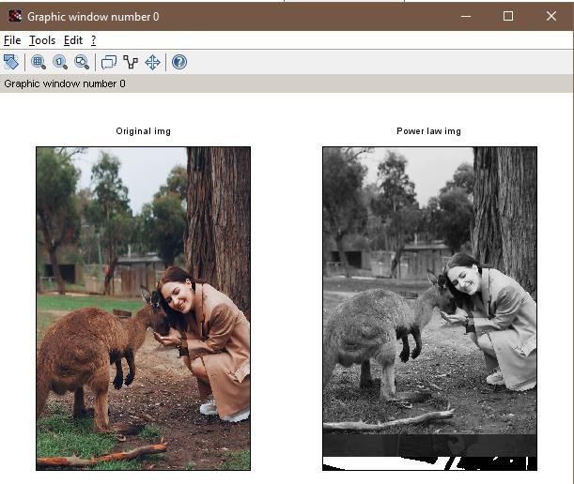

**2.e) Piecewise linear transformations**

**Code :**

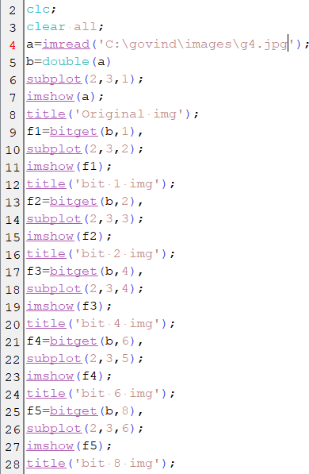

**Output:**

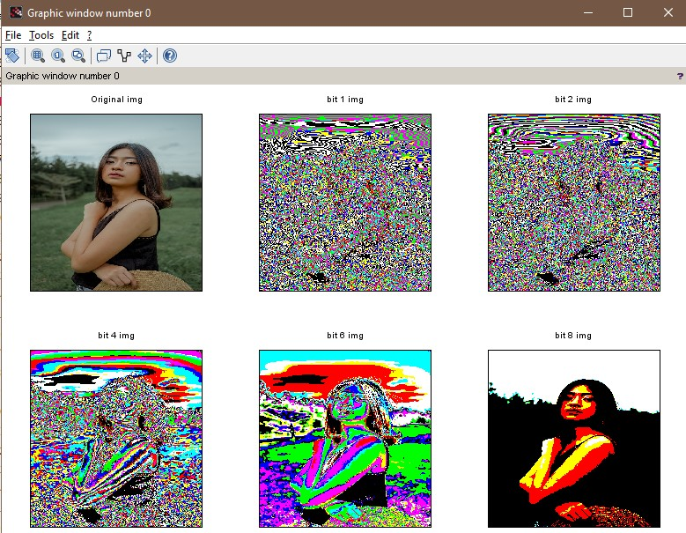

# Practical No : 3

**Aim: Program to plot the histogram of an image and categorise**

**Description:**

An **image histogram** is a type of **histogram** that acts as a graphical representation of the tonal distribution in a digital **image**. It plots the number of pixels for each tonal value.

By looking at the **histogram** for a specific **image** a viewer will be able to judge the entire tonal distribution at a glance.

**Code :**

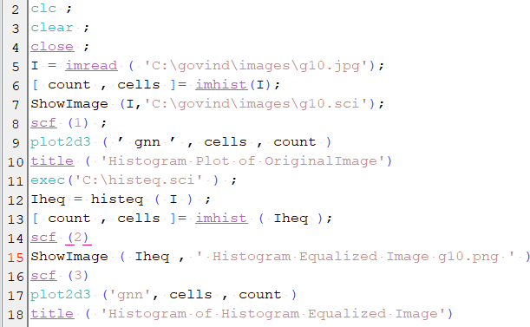

**Output:**

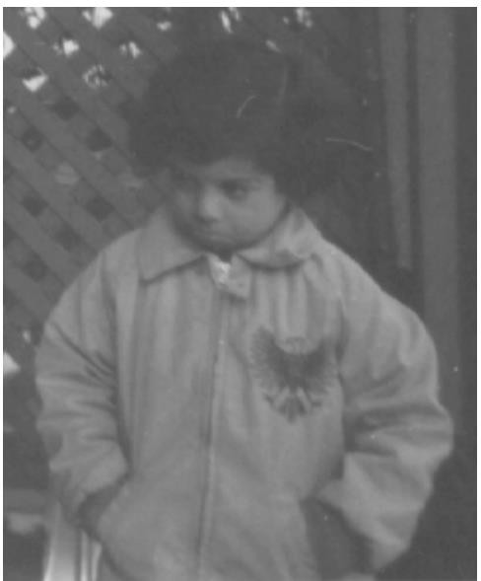

# Practical No : 4

**Aim: Program to read a color image and segment into RGB planes , histogram of color image**

**Description :**

**Color image processing** is divided into two major areas: full-**color** and pseudo-**color processing**. In the first category, the **images** in question typically are acquired with a full-**color** sensor, such as a **color** TV camera or **color** scanner

**Code :**

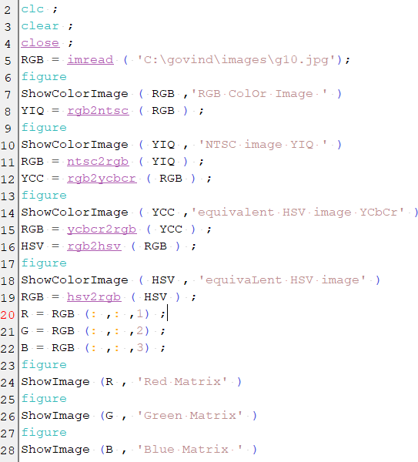

**Output:**

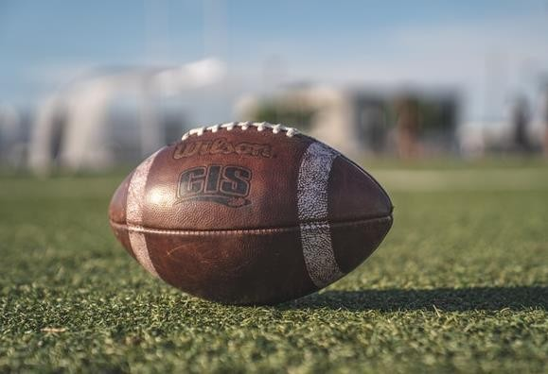

# Practical No : 5

**Aim: Program to apply Discrete Fourier Transform on an image**

**Description:**

In mathematics, the **discrete Fourier transform** (**DFT**) converts a finite sequence of equally-spaced samples of a function into a same-length sequence of equally-spaced samples of the **discrete**-time **Fourier transform** (DTFT), which is a complex-valued function of frequency.

**Code :**

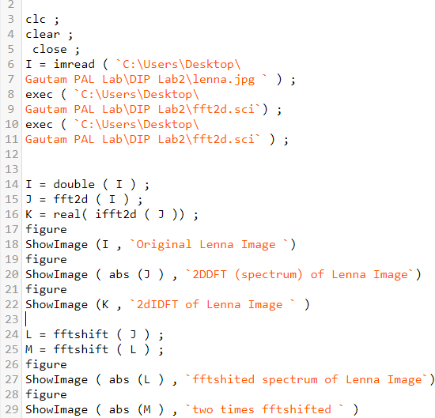

# Practical No : 6

**Aim: Program to apply erosion, dilation, opening, closing**

**Code :**

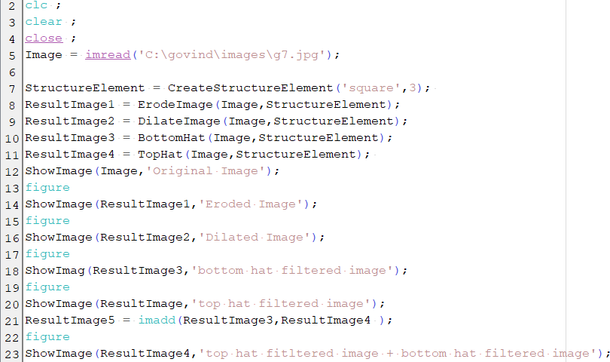

**Output:**

